1. /customers/list – Home page when there is no entry:

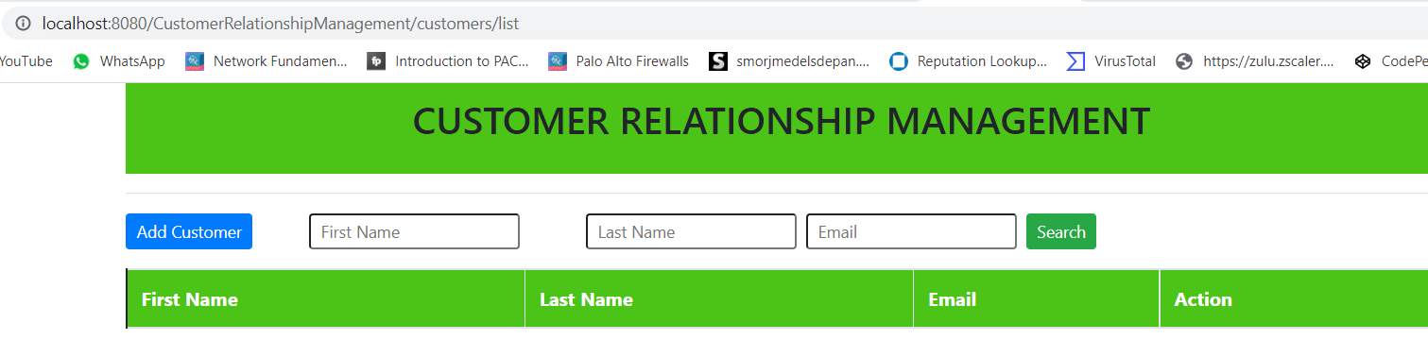

1. Saving first customer:

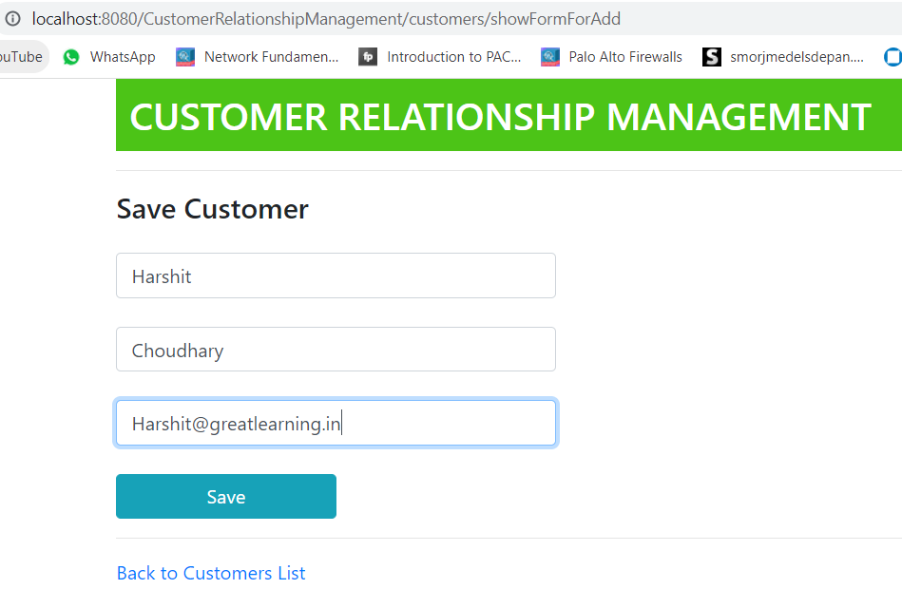

1. After adding one customer:

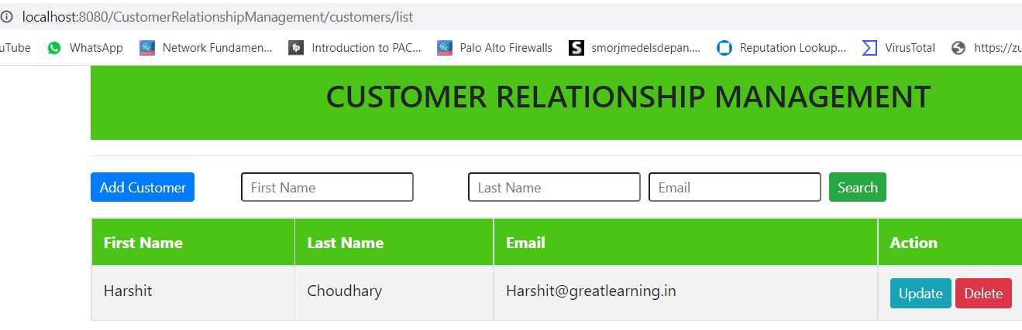

1. After adding/saving 4 customers:

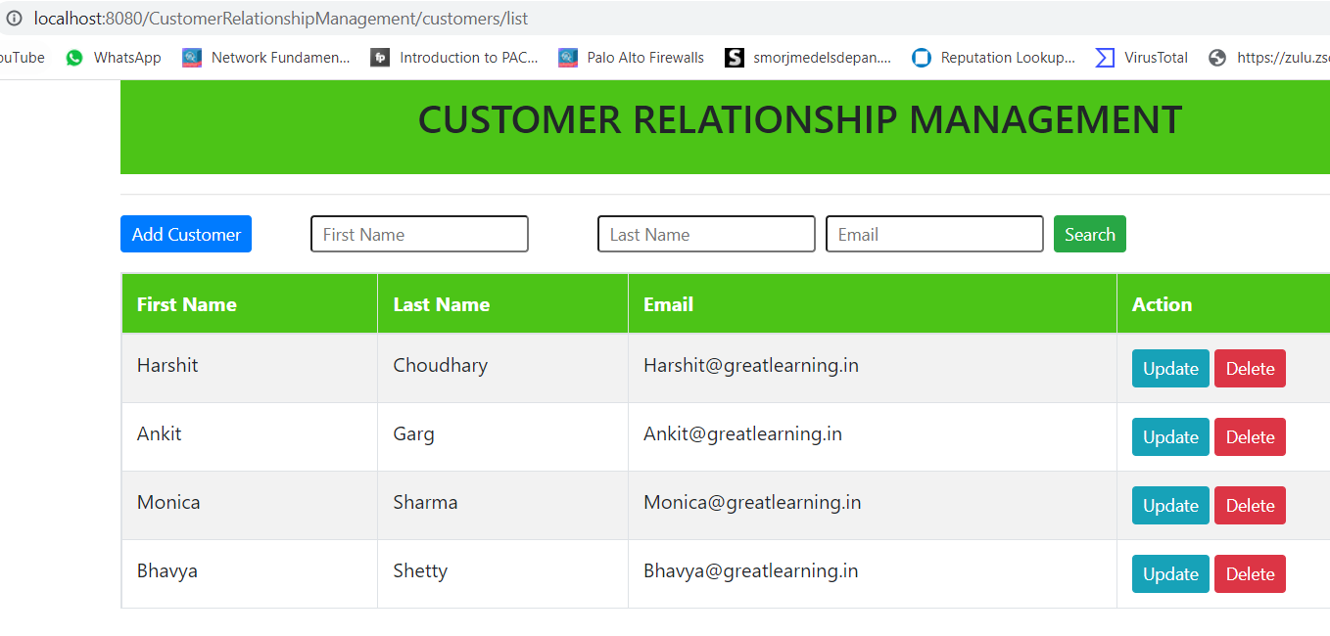

1. Updating harshit email address from @greatlearning.in to @gmail.com:

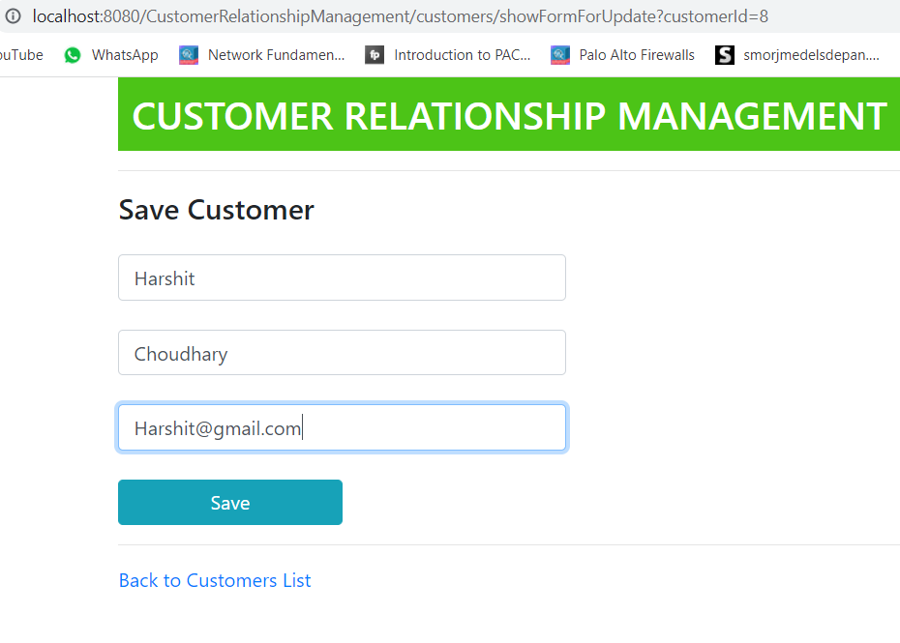

1. After update of email id:

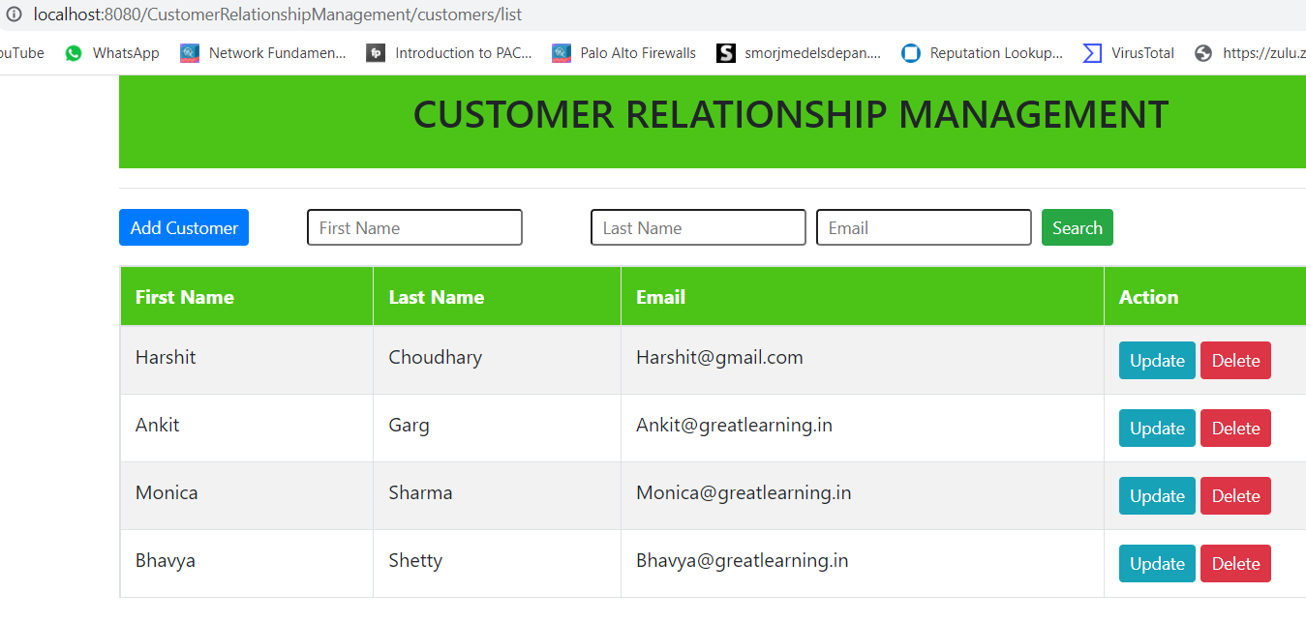

1. Deleting harshit chaudhary entry:

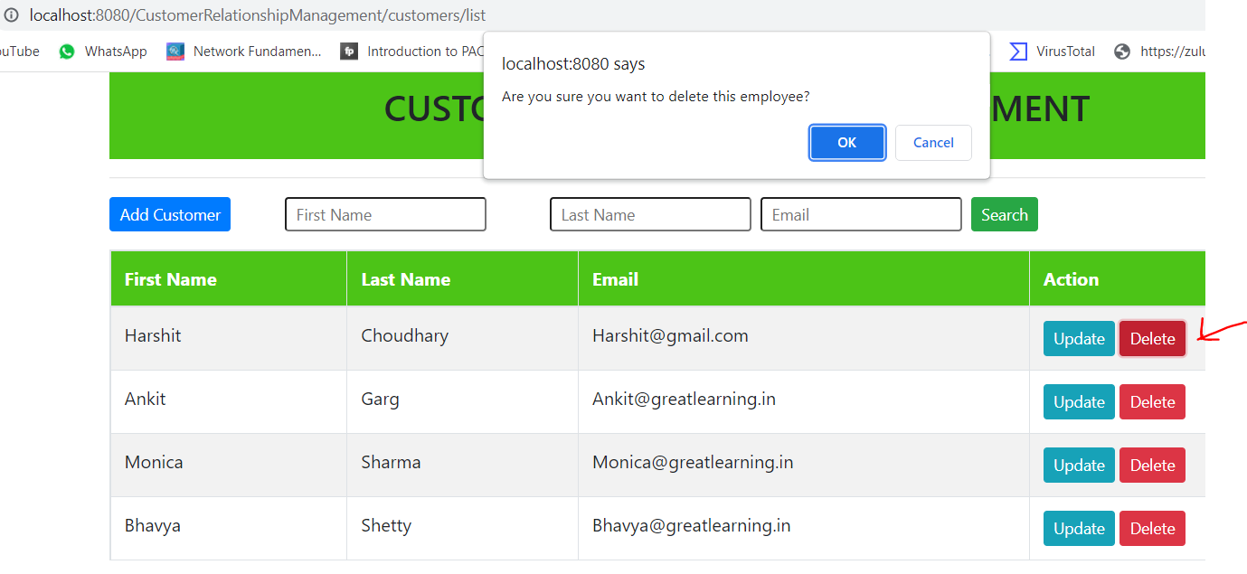

1. Harshit Choudhary is deleted successfully:

